Advanced QGIS (NESAC Workshop)

Automate your workflows and explore hidden features of QGIS

**Contents**

Batch Processing 2

Key Concepts . . . . . . . . . . . . . . . . . . . . . . . . . . . . . . . . . . . . 2

Processing Modeler for Automating Complex Workflows 2

Key Concepts . . . . . . . . . . . . . . . . . . . . . . . . . . . . . . . . . . . . 3

Exercise . . . . . . . . . . . . . . . . . . . . . . . . . . . . . . . . . . . . . . . 3

Print Layer Atlas for Batch Map Creation 3

Key Concepts . . . . . . . . . . . . . . . . . . . . . . . . . . . . . . . . . . . . 4

Network Analysis 5

Building a Network and Route Finding . . . . . . . . . . . . . . . . . . . . . . 5

Key Concepts . . . . . . . . . . . . . . . . . . . . . . . . . . . . . . . . . 5

Origin-Destination Analysis . . . . . . . . . . . . . . . . . . . . . . . . . . . . 6

Key Concepts . . . . . . . . . . . . . . . . . . . . . . . . . . . . . . . . . 6

Service Area Analysis . . . . . . . . . . . . . . . . . . . . . . . . . . . . . . . . 7

Key Concepts . . . . . . . . . . . . . . . . . . . . . . . . . . . . . . . . . 7

1

2

# Batch Processing

Project: batch_processing.qgz

## Key Concepts

* Variables
* QGIS Locator Bar (Ctrl + K)
* GeoPackage
* Browser Panel for quick import
* Important: Processing Modeler Settings - *Use filename as layer name*

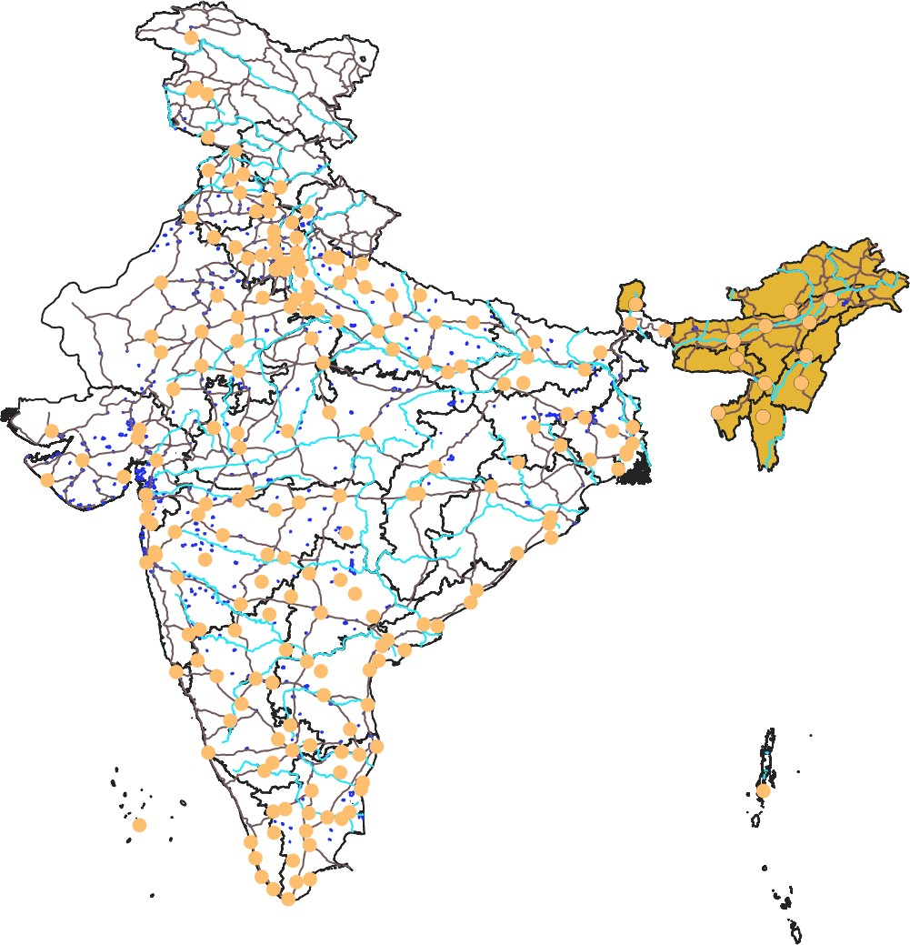

Fun fact: Time for an easter egg

# Processing Modeler for Automating Complex Work- flows

Project: maritime_piracy.qgz Project: assam_roads.qgz

## Key Concepts

* Equal Earth Projection
* Custom CRS **Settings → Custom Projection**

+proj=eqearth +datum=WGS84 +wktext

* Layer Styling Panel
* Data Defined Overrides for Styling
* Saving models in Projects

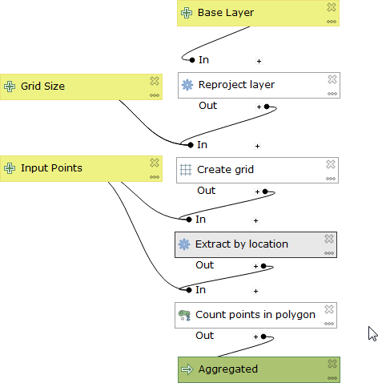

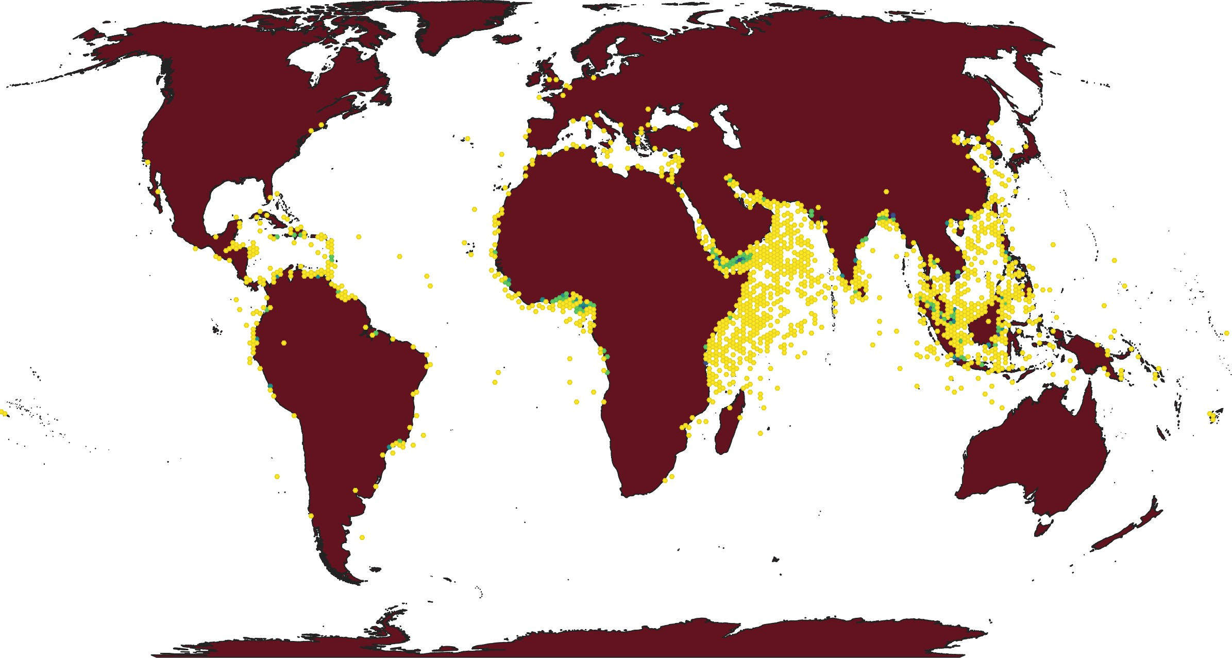

Fun fact: Time for another easter egg.

## Exercise

Open project assam_roads.qgz. Create a model to produce a district layer that has total length of roads contained in each district.

# Print Layer Atlas for Batch Map Creation

Project: meghalaya.qgz

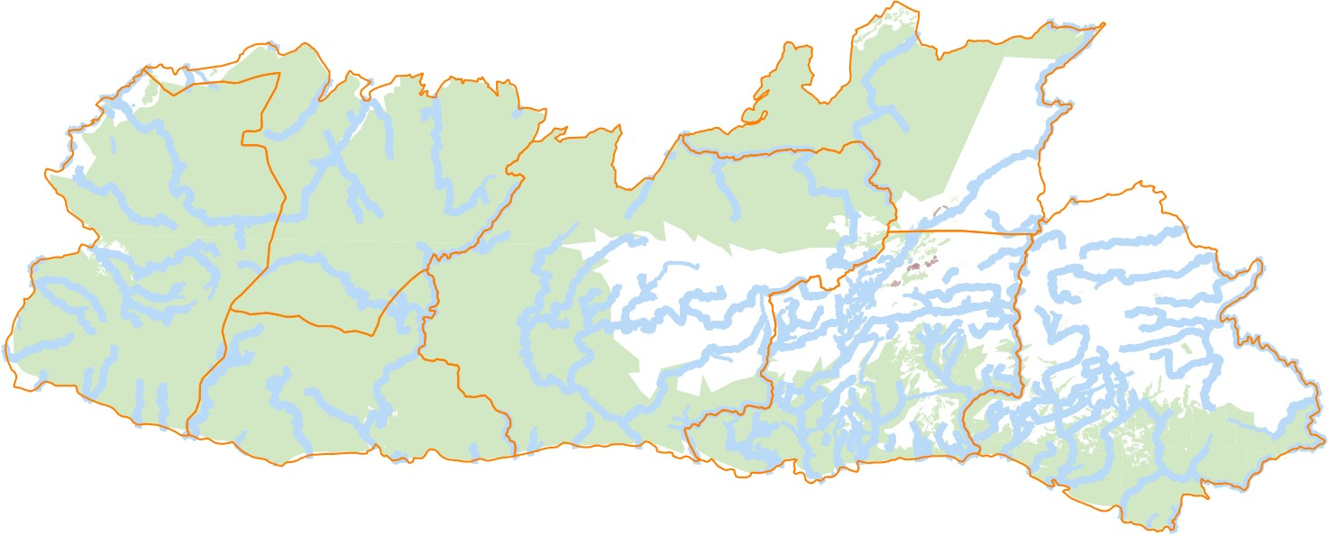

## Key Concepts

* Atlas tool
* atlas variables
* $id = @atlas_featureid
* Inverted polygon renderer

5

